Supporting Information
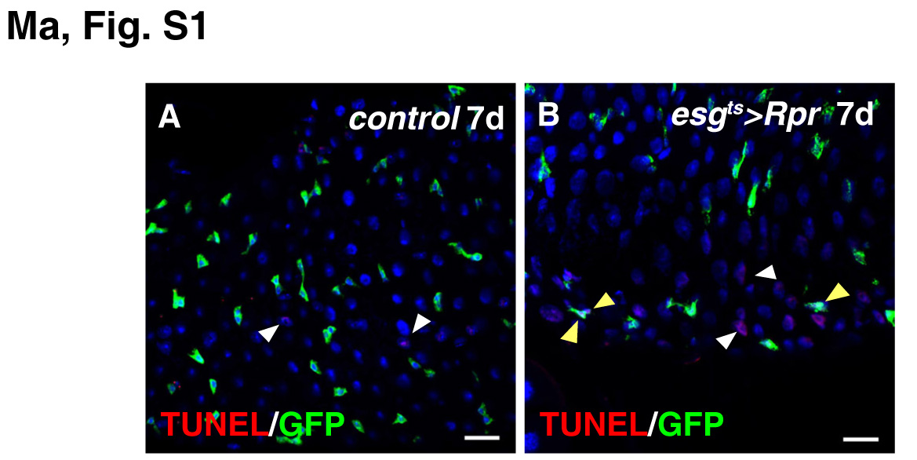
Fig. S1. Overexpression of Rpr causes progenitor cell death.
(A) TUNEL assay of control intestines. No progenitor cell death could be observed, except that some ECs are undergoing cell death (red, white arrowheads). (B) TUNEL assay of esg^{ts}>Rpr intestines. Some progenitors are undergoing cell death (red, yellow arrowheads). Dying ECs (red, white arrowheads) can also be observed. Blue indicates DAPI staining for DNA. Scale bars: 20 μm.
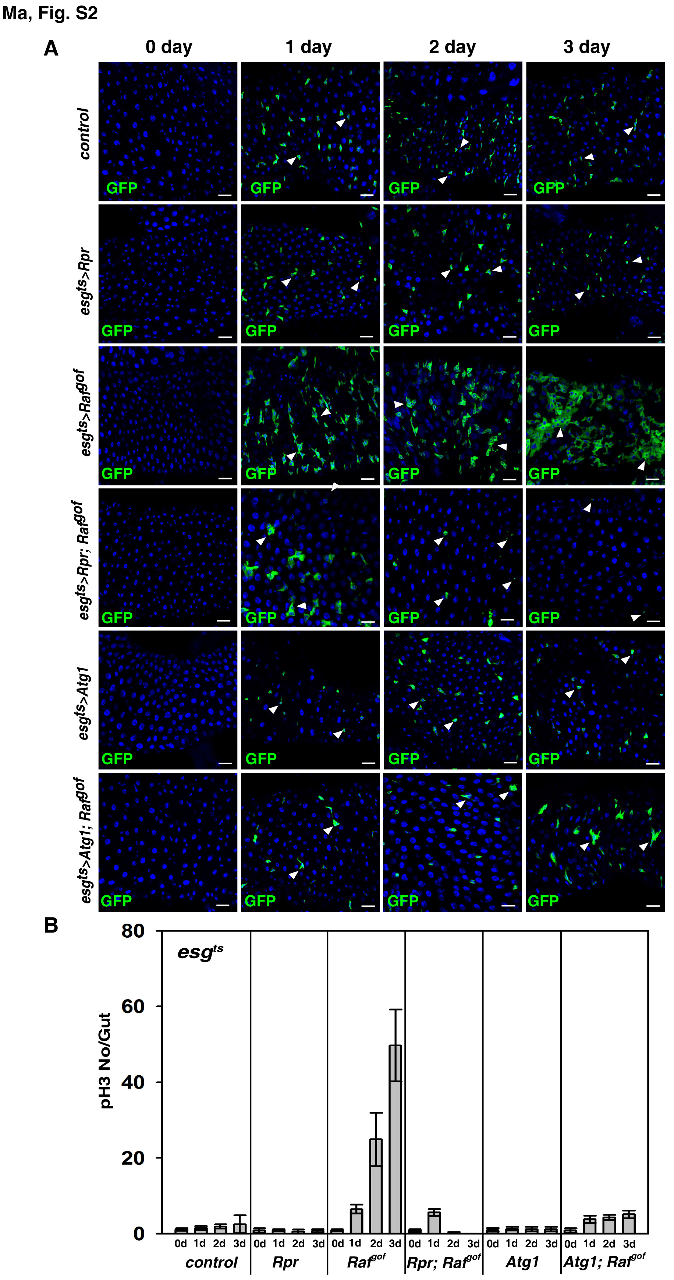
Fig. S2. Overexpression of Rpr ablates all Raf^{gof} tumor cells, while Atg1 induction inhibits Raf^{gof} tumor formation.
(A) A time course analysis in the intestines of different genotypes (from 0 to 3 days). 0 day: flies hatched from 18゜C incubator were dissected and fixed, thereby no GFP expression was observed. A transient increase of ISC number was detected in esg^{ts}>Rpr; Raf^{gof} intestines at day 1 (white arrowheads). Most of the esg+ cells expressing Rpr and Raf^{gof} at the 2nd day were morphologically abnormal and some cell debris were observed (white arrowheads), only some cell debris were observed at the 3rd day (white arrowheads). Raf^{gof} tumors were significantly suppressed by Atg1 co-induction (white arrowheads). GFP in green, blue indicates DAPI staining for DNA. Scale bars: 20 μm. (B) Quantification of pH3 staining per gut in the intestines of different genotypes at different time points. n = 10-15 intestines. Mean ± SD is shown.

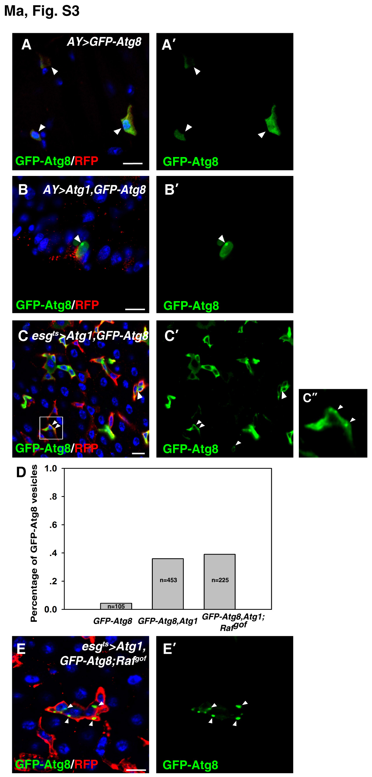
Fig. S3. Overexpression of Atg1 induces autophagosome formation.
(A, A’) Autophagosomes are rarely observed in ActGal4 FLP-out clones (AY, red) expressing GFP-Atg8 alone (white arrowheads). (B, B’) Autophagosomes (green, GFP-Atg8/LC3) are readily observed in AY clones (red) expressing both Atg1 and GFP-Atg8 (white arrowhead). (C-C’’) Autophagosomes (green, GFP-Atg8/LC3) are readily observed in progenitors (red) expressing both Atg1 and GFP-Atg8 using esg^{ts} (white arrowheads). (D) Quantification of the percentage of cells containing autophagosomes (GFP-Atg8 vesicles) in GFP-positive cells. For an unknown reason, when Atg1 and GFP-Atg8 were co-expressed, some of the RFP positive cells did not contain the GFP-Atg8 signal. (E, E’) Large autophagosomes (green, GFP-Atg8/LC3) are observed in progenitors expressing Atg1, GFP-Atg8, and Raf^{gof} using esg^{ts} (white arrowheads). Blue indicates DAPI staining for DNA. Scale bars: 10 μm.

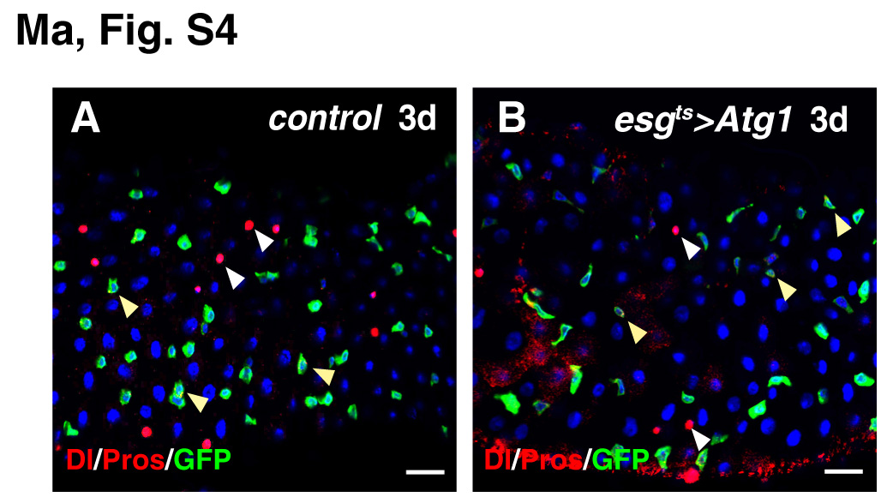
Fig. S4. Progenitor identity and progeny differentiation are not affected by the expression of Atg1 at 3 days.
(A) Progenitors (Dl in red, yellow arrowheads) and ee cells (Pros in red, white arrowheads) in control intestines. (B) Progenitor identity (Dl in red, yellow arrowheads) and ee cell differentiation (Pros in red, white arrowheads) in esg^{ts}>Atg1 intestines. Blue indicates DAPI staining for DNA. Scale bars: 20 μm.

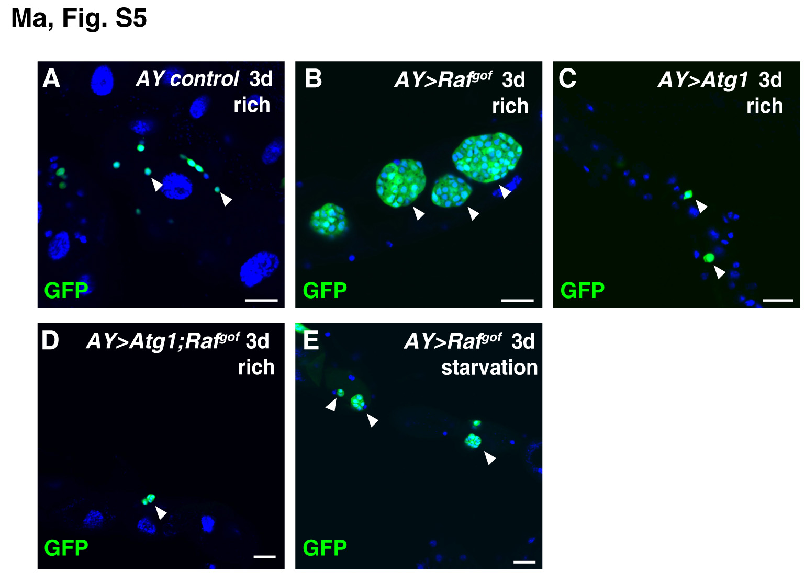
Fig. S5. Renal tumors induced by Raf^{gof} expression are inhibited by autophagy induction.
(A) Control AY renal clones grown in well-fed flies (rich medium) at 29 ºC for 3 days (white arrowheads). (B) Renal tumors are formed in well-fed animals after AY induction of Raf^{gof} at 29 ºC for 3 days (white arrowheads). (C) AY renal clones grown in well-fed flies expressing Atg1 at 29 ºC for 3 days (white arrowheads). (D) Renal Raf^{gof} tumors are significantly inhibited by co-expressing Atg1 (white arrowhead). (E) Renal Raf^{gof} tumors are significantly inhibited under starvation (white arrowheads). Blue indicates DAPI staining for DNA. Scale bars: 20 μm.
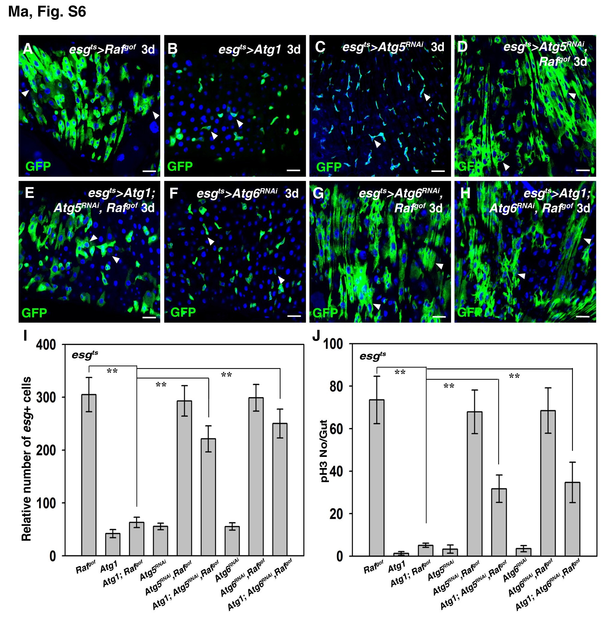
Fig. S6. Autophagy is required for the inhibition of Raf^{gof} tumors.
(A) Intestinal tumors are formed in esg^{ts}>Raf^{gof} intestines at 29°C for 3 days (white arrowheads). (B) No obvious defects are observed in esg^{ts}>Atg1 intestines (white arrowheads). (C) Intestines with knockdown of Atg5 (progenitors in green, white arrowheads). (D) Intestinal tumors are formed in esg^{ts}>Atg5^{RNAi}, Raf^{gof} intestines at 29°C for 3 days (white arrowheads). (E) Atg5 RNAi significantly rescues the inhibition of tumor formation observed in esg^{ts}>Atg1, Raf^{gof} intestines (white arrowheads). (F) Intestines with knockdown of Atg6 (progenitors in green, white arrowheads). (G) Intestinal tumors are formed in esg^{ts}>Atg6^{RNAi}, Raf^{gof} intestines at 29°C for 3 days (white arrowheads). (H) Atg6 knockdown significantly rescues the inhibition of tumor formation observed in esg^{ts}>Atg1, Raf^{gof} intestines (white arrowheads). (I) Quantification of the relative number of esg+ cells in the intestines of different genotypes. Note that because esg^{ts}>Raf^{gof} intestines are highly deformed due to the formation of tumors, it is very difficult to accurately count the number of esg+ cells in these intestines. n = 10-15 intestines. Mean ± SD is shown. **p<0.001. (J) Quantification of pH3 staining per gut in the intestines of different genotypes. n = 10-15 intestines. Mean ± SD is shown. **p<0.001. Blue indicates DAPI staining for DNA. Scale bars: 20 μm.

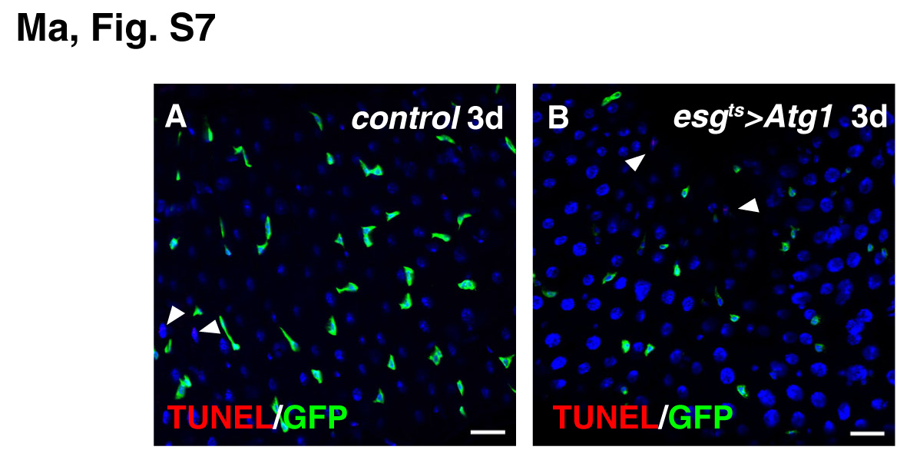
Fig. S7. Overexpression of Atg1 does not cause progenitor cell death.
(A) TUNEL assay of control intestines. No progenitor cell death could be observed, except that some ECs are undergoing cell death (red, white arrowheads). (B) TUNEL assay of esg^{ts}>Atg1 intestines. No progenitor cell death could be observed. Dying ECs (red, white arrowheads) can be observed. Blue indicates DAPI staining for DNA. Scale bars: 20 μm.

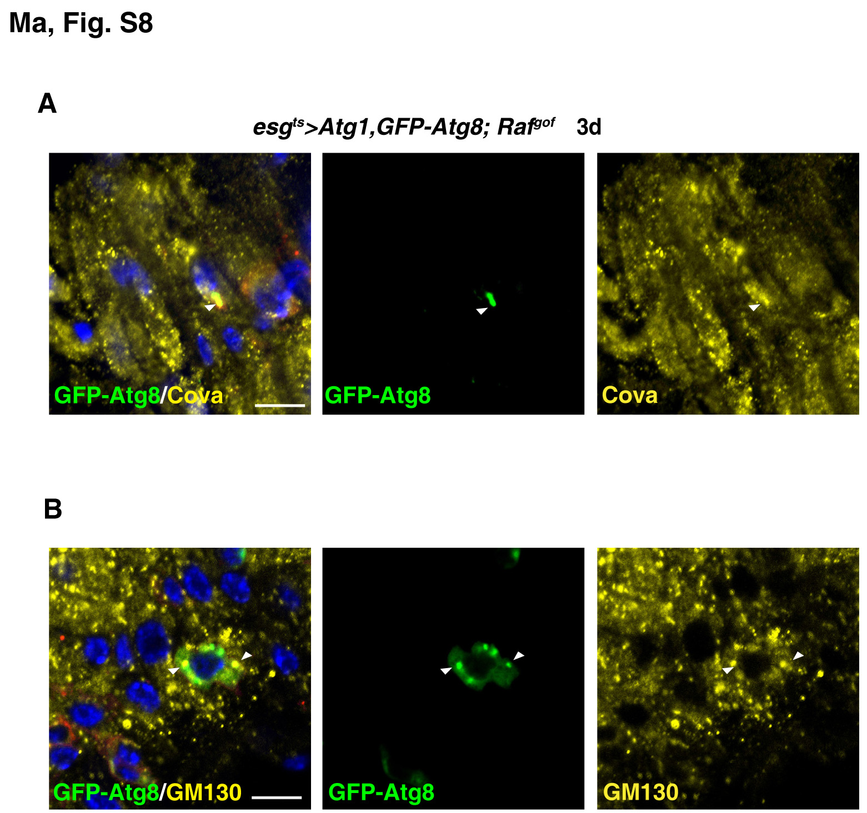
Fig. S8. Mitochondria and golgi apparatus are engulfed in autophagosomes in esg^{ts}>Atg1, GFP-Atg8; Raf^{gof}/UAS-mRFP cells.
(A) Mitochondria (Cova, yellow) are present within the autophagosomes (green, labeled with GFP-Atg8) (white arrowhead). (B) Golgi apparatus (GM130, yellow) are observed in the autophagosomes (green, labeled with GFP-Atg8) (white arrowheads). For an unknown reason, when Atg1 and GFP-Atg8 were co-expressed, some of the RFP positive cells did not contain the GFP-Atg8 signal. mRFP in red. Blue indicates DAPI staining for DNA. Scale bars: 10 μm.

